Financial Conflicts of Interest: Overview, Investigator Responsibilities, and COI Rules (COI-Basic)
Content Authors
- Janet Holcombe, JD
The Children's Hospital of Philadelphia
- Charlotte Talman, MSN, MBA
The University of Iowa

Introduction
Federal agencies, such as the U.S. Public Health Service (PHS), National Science Foundation (NSF), Department of Energy (DOE), National Aeronautics and Space Administration (NASA), and Environmental Protection Agency (EPA), have adopted specific regulations on financial conflicts of interest (FCOIs) to promote objectivity in federally funded research. Researchers must be familiar with the regulations and their institutional policies regarding conflicts if they have or plan to have responsibility for the design, conduct, or reporting of such research. This module focuses on the PHS regulations.
Learning Objectives
By the end of this module, you should be able to:
- Describe how PHS regulations relate to FCOIs.
- Recognize various forms of FCOIs in research.
- Identify the research team members who are subject to FCOI requirements.
- Identify the significant financial interests (SFIs) that investigators must disclose to their institutions.
- Recognize the ongoing obligations that investigators have relating to FCOIs.

Conflicts of Interest: An Overview

Professionalism and the Ethical Conduct of Research
A conflict of interest (COI) is any circumstance where the personal, professional, financial, or other private interests of a person or institution compromise or have the potential to compromise the exercise of professional judgment or obligations or may be perceived as doing so.
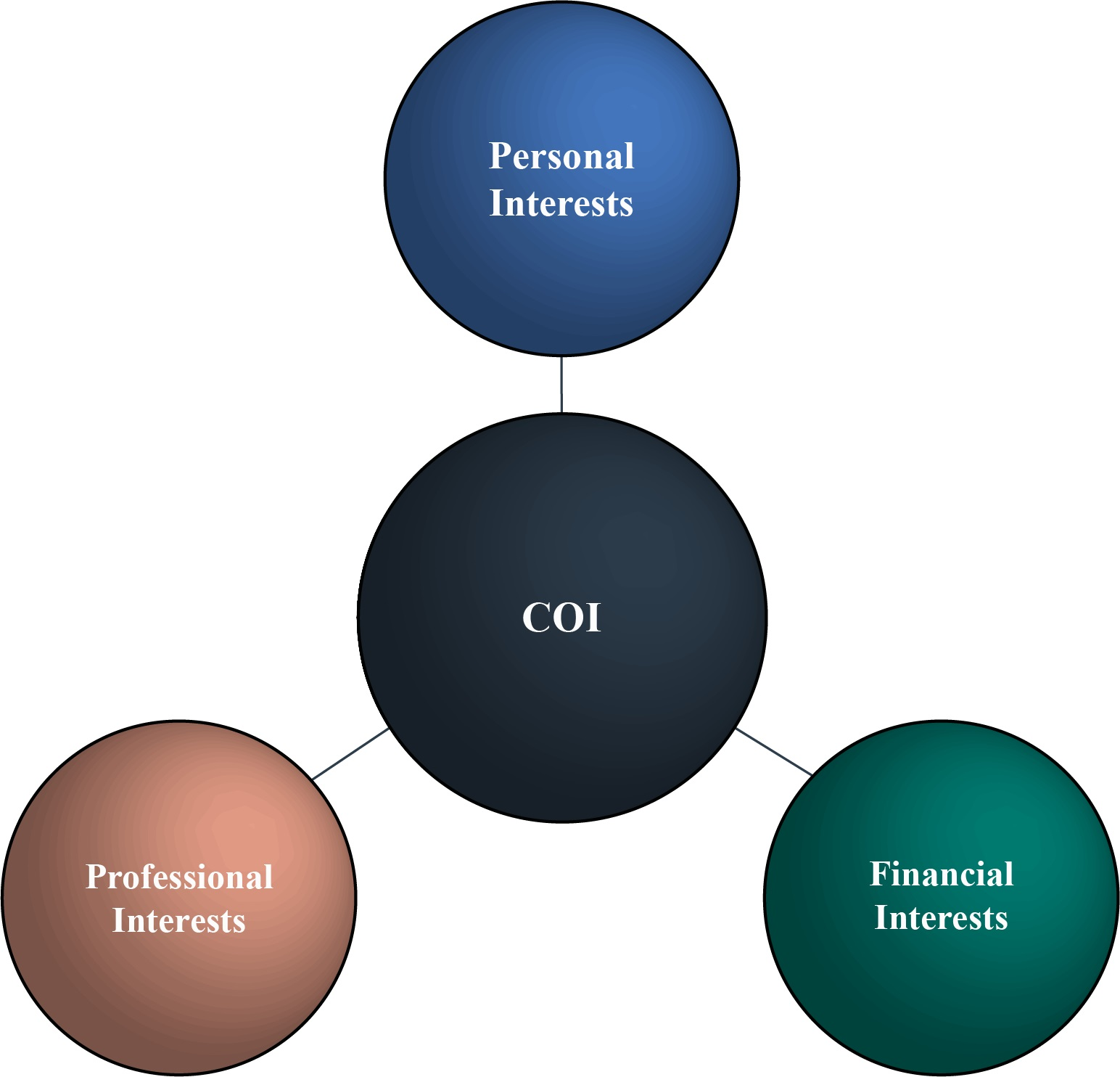
Research COI can take many forms. For example:
- Close personal or working relationships with peers or mentors may have the potential to influence the independence of a researcher's judgment or actions, sometimes in subtle ways that even the researcher does not perceive.
- Pressure on faculty or others to publish may also introduce bias at various points in the research process, whether during the stage of study design, recruitment of study subjects (for research involving human subjects), data analysis, or the selection of which results to publish.
- Researchers may also have external professional commitments that, while important, are so extensive they conflict with their primary teaching, clinical (if relevant), and research obligations at their own institutions (typically referred to as a conflict of commitment).
While nonfinancial factors affecting professional judgment are important, this module focuses on the potential for financial interests of individual researchers, and those of their immediate family members, to affect the design, conduct, or reporting of their research. Examples of these interests include the receipt of personal compensation for consulting activity, ownership of equity in publicly or privately held businesses, and receipt of income from intellectual property rights held by the researcher.
Public trust in the integrity of research depends upon the existence of an effective process for identifying FCOIs and acting to promote and maintain objectivity in the research. As noted by Dr. Francis Collins, former director of the National Institutes of Health (NIH), "The public trust in what we do is just essential, and we cannot afford to take any chances with the integrity of the research process" (Wadman 2010).

Historical Overview
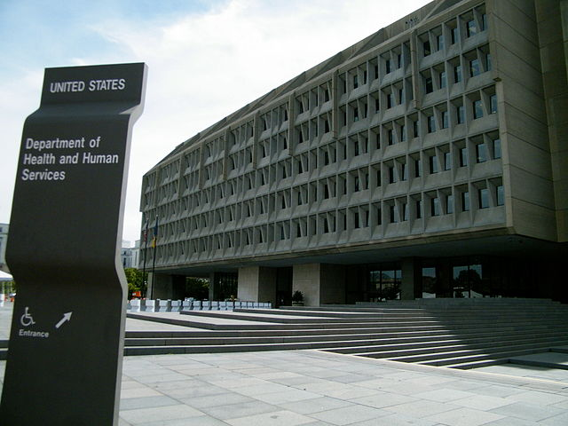
In 1995, the U.S. government began regulating FCOIs in federally sponsored research. Issued by the Office of the Secretary of the U.S. Department of Health and Human Services (HHS) and the PHS, the 1995 regulations apportioned responsibilities between institutions receiving PHS research funding and the investigators involved in the research, to promote objectivity by disclosing, managing, and reporting, if not eliminating, significant financial interests that constitute financial conflicts of interest (Responsibility of Applicants 1995; Responsible Prospective Contractors 1995).
In the decades after the publication of the federal rules, "biomedical and behavioral research and the resulting interactions among government, research [i]nstitutions, and the private sector have become increasingly complex" (HHS 2011). During that time, funding for biomedical research nearly tripled, with over half of the funding coming from industry, not government, sources. Since then, relationships between academic researchers and industry have increased dramatically. "Researchers frequently work in multidisciplinary teams to develop new strategies and approaches for translating basic research into clinical application, thus hastening discovery and advancing human health" (HHS 2011).
In August 2011, taking note of these developments, along with growing public scrutiny and the possible ramifications of the increasingly complex relationships between biomedical researchers and private industry, HHS issued a Final Rule amending the regulations:
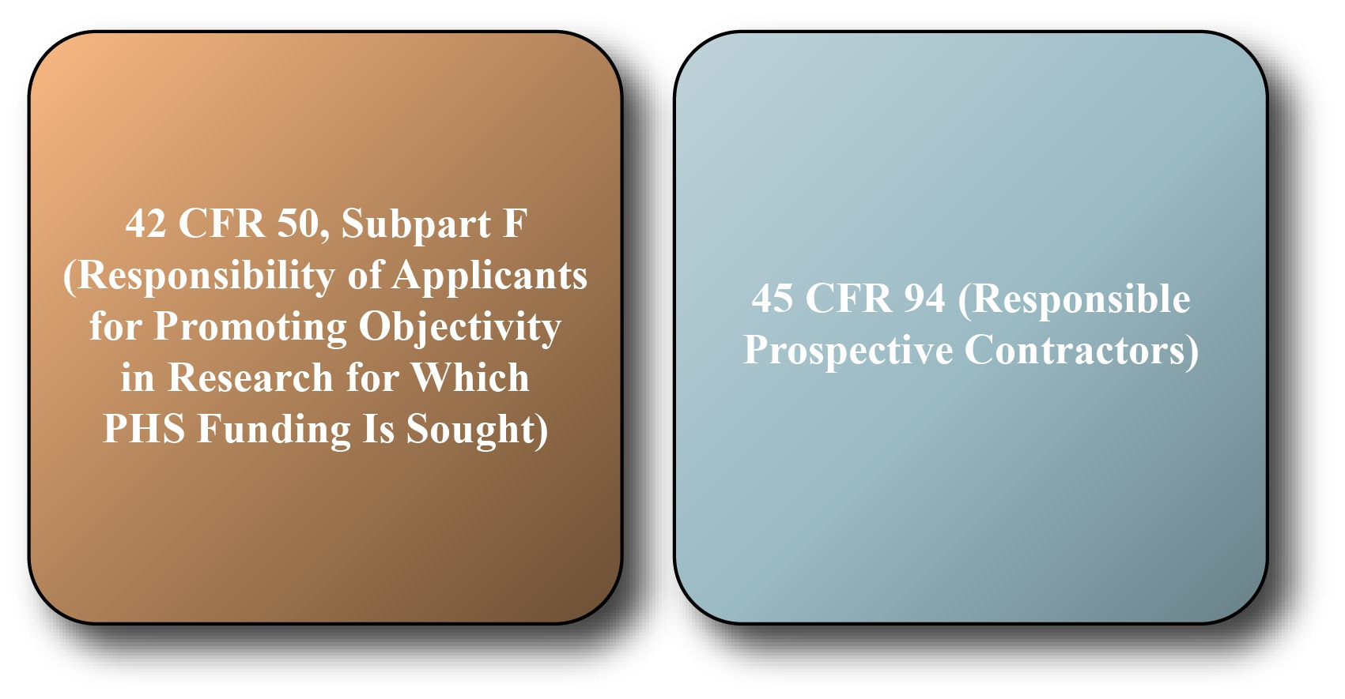
This module focuses on the regulations applicable to research funded under PHS grants or cooperative agreements, 42 CFR 50, Subpart F. The other regulation, 45 CFR 94, applies to institutions conducting research as contractors to NIH.
Separate standards on COI apply to research funded by the NSF and other federal agencies. For example, the NSF (2023) standards are similar in many ways to the PHS regulations, but they differ in some respects, such as the thresholds for disclosure of an investigator's outside compensation and the requirement to disclose venture or other capital financing.
The U.S. Food and Drug Administration (FDA) also has its own set of COI regulations at 21 CFR 54 (Financial Disclosure by Clinical Investigators 1998), requiring the sponsor of a clinical trial to provide certain financial interest information about the clinical trial investigators when submitting a marketing application for a drug, biological product, or device. On a related note, the FDA (2013) has provided a document titled Guidance for Clinical Investigators, Industry, and FDA Staff Financial Disclosure by Clinical Investigators.

The HHS/PHS Federal Regulations
The 2011 regulations apply to all PHS-funded research available through a grant or cooperative agreement, including biomedical, behavioral, and social science research. PHS-funded research runs the gamut from basic research to applied research and product development (for example, a diagnostic test or drug).
The regulations intend to promote objectivity in research by establishing standards that provide a reasonable expectation that the design, conduct, and reporting of federally funded research will be free from bias resulting from investigators’ FCOIs.
More specifically, the revised regulations:
- Implement required training for investigators.
- Expand the scope and definition of SFIs that investigators must disclose, with, for example, lower thresholds for some types of SFIs.
- Intensify the responsibilities of institutions for review, management, and oversight of investigators' SFIs and FCOIs.
- Increase compliance oversight obligations for institutions and the government.
Some institutions have decided to apply the reporting requirements contained with the PHS regulations to researchers funded by other (non-PHS) sources. The next section in this module outlines the key provisions of the PHS regulations, including the responsibilities of investigators and institutions.
The NIH Financial Conflict of Interest website provides additional resources and information about the regulations, including FAQs.

Investigator Responsibilities and COI Rules

The regulations are applicable to each investigator who will participate in research funded under PHS grants or cooperative agreements. The term investigator means the project director or principal investigator and any other person, regardless of title or position, who is responsible for the design, conduct, or reporting of PHS-funded research or proposals for such funding. Therefore, the regulations can apply to collaborators, consultants, postdoctoral fellows, graduate students, and others. The regulations apply to both the awardee institution and subrecipient organization for any individual who meets the definition of "investigator." Even if they are not seeking funding from PHS, investigators should refer to the terms and conditions of the particular grant program and their institutional policies to determine whether the PHS regulations apply.
It is important to note that although PHS regulations may not apply to Small Business Innovative Research (SBIR) and Small Business Technology Transfer (STTR) Program Phase I applications and awards, individual institutions and subrecipients may continue to enforce institutional or PHS policy.
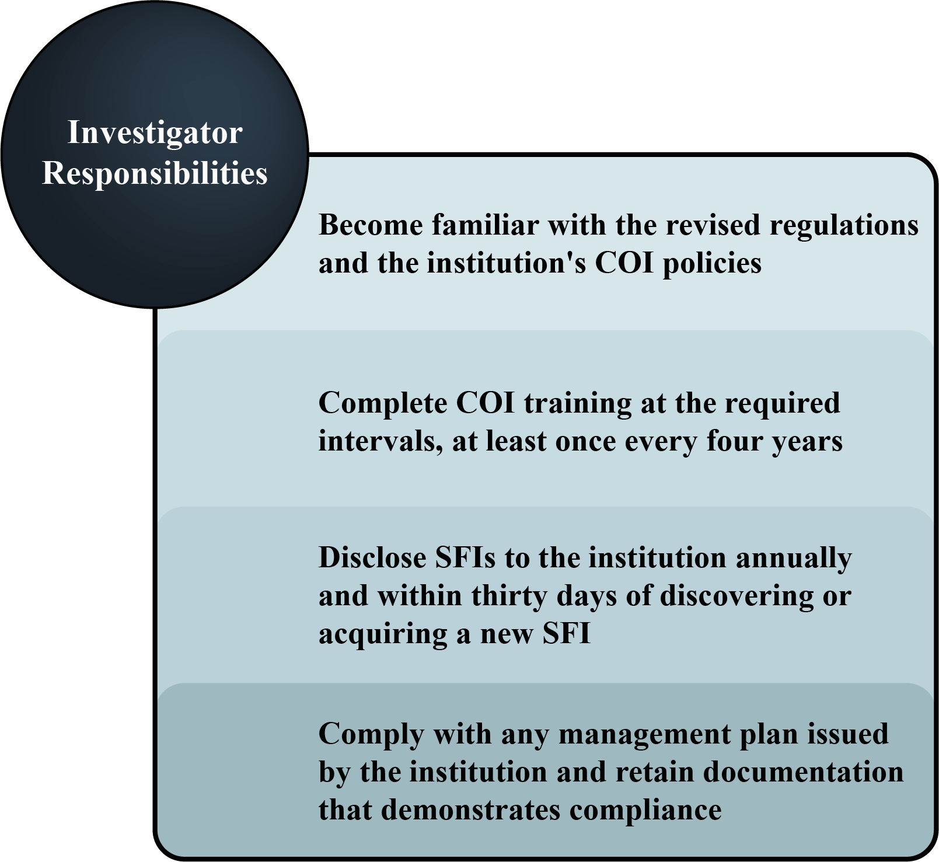
The institution must notify investigators of the regulations and the related institutional policy on FCOI, including investigators' responsibilities. In that regard, investigators must complete training prior to engaging in PHS-funded research and re-train every four years thereafter. Institutions may require training under other circumstances, such as an investigator's failure to properly disclose SFIs or noncompliance with a management plan.
The cornerstone of managing COI is transparency, which begins with the investigator's disclosure of significant financial interests or SFIs that relate to the institution. An SFI is anything of monetary value, whether or not the value is readily ascertainable, that (Responsible Prospective Contractors 2011):
- Relates to the "Investigator's professional responsibilities on behalf of the Institution including, but not limited to, activities such as research, research consultation, teaching, professional practice, institutional committee memberships, and service on panels"
- Belongs to the investigator or the investigator's spouse or dependent children
Investigators who are planning to participate in PHS-funded research must disclose certain types of financial interests that relate to their institutional responsibilities. More specifically, they must disclose the following SFIs to their institution no later than the time of applying for funding (HHS 2011; NIH 2015):
- Income in excess of $5,000 from a publicly-traded entity (a company whose stock is available for purchase by the general public) during the past 12 months.
- Stock valued in excess of $5,000 at the time of disclosure in a publicly-traded entity.
- A combination of the above two items (stock and income) that exceeds $5,000.
- Any amount of equity (stock, stock options, or other ownership interest) in a non-publicly traded entity (such as a start-up company).
- Compensation that exceeds $5,000 from a non-publicly traded entity in the past 12 months.
- Income related to intellectual property rights paid by any source other than the investigator's current institution. (Per NIH guidance, income related to intellectual property rights and interests that exceeds $5,000 is a significant financial interest.)
- Reimbursed or sponsored travel paid by an entity, including non-profit organizations, but excluding travel sponsored or reimbursed by a U.S. government agency, a U.S. institution of higher education, or one of the following U.S. institutions affiliated with a U.S. institution of higher education: a research institute, a medical center, or an academic teaching hospital. The specific details that investigators must disclose are the name of an entity sponsoring the travel and purpose, destination, and duration of the travel. Notice Number: NOT-OD-13-004 provides more information on the NIH’s policy on travel disclosure.
- Any other interests required under the institution's policy.
The investigator does not need to disclose (HHS 2011):
- Salary, royalties, or other remuneration paid to the investigator from the institution that currently employs the investigator. Any ownership interest in the institution held by the investigator if the institution is a commercial or for-profit organization.
- Income from investments in mutual funds or retirement accounts, as long as the investigator does not make the investment decisions.
- Income for services (for example, honoraria, advisory committees, or review panels) and travel expenses paid by a federal, state, or local government agency, a U.S. institution of higher education, or a research institute affiliated with a U.S. institution of higher education, a medical center, or an academic teaching hospital.
Note: The NIH issued a notice in 2018 reminding investigators and organizations that the reporting exclusions pertaining to federal, state, or local government agencies and institutions of higher education only apply to those within the U.S. The notice stated, “Investigators, including subrecipient investigators, must disclose all financial interests received from a foreign institution of higher education or government of another country (which includes local, provincial, or equivalent governments of another country)” (NIH 2018).
Each investigator must update the disclosure at least annually during the period covered by the grant, or within 30 days of identifying or acquiring a new SFI.
With respect to the provisions outlined in the federal regulations, institutions may have more, but not less, stringent policies. For example, while the new regulations do not require disclosure of royalties paid through the institution to an investigator, the institution might require disclosure of such royalties. Investigators must review their institution's COI policies to make sure that they disclose the information specifically required by those policies.
Dr. Miller’s Start-up Company
It is the institution’s responsibility to determine whether any of an investigator's SFIs could directly and significantly affect the research, or is in an entity whose financial interest could be affected by the research; if it is determined that either of these conditions is present, an FCOI exists.
If the institution makes an FCOI determination, prior to the expenditure of any research funds, it must develop and implement a management plan to reduce or eliminate the FCOI, and ensure, to the extent possible, that the research will be free from bias. Common management plan elements include:
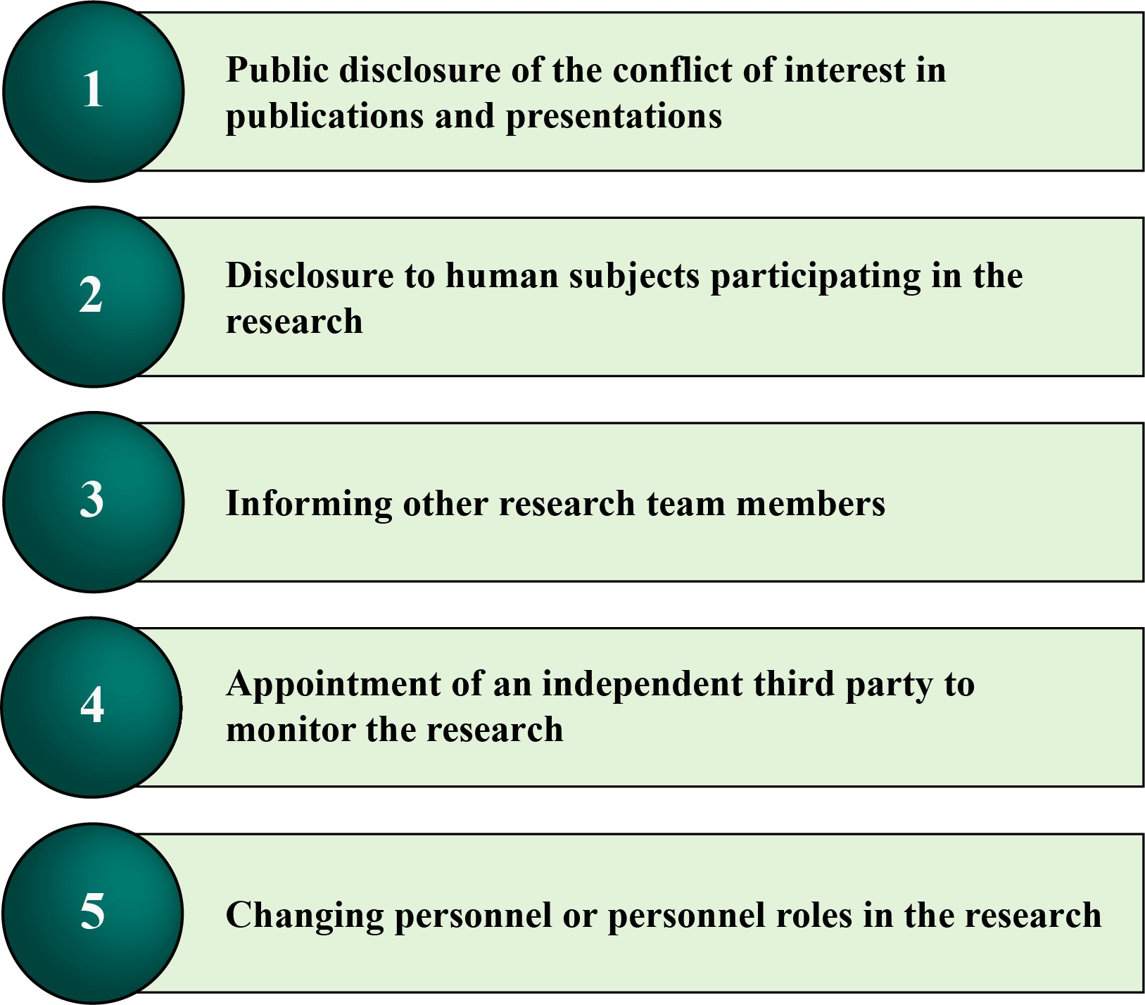
The Biomarker Test
The investigator must confirm agreement with the institution's management plan, and the institution must monitor the investigator's ongoing compliance with the management plan on an annual basis during the period of the research award. Therefore, it is the responsibility of the investigator to verify compliance by retaining documents such as notices to journal editors or conference audiences, consent forms from human subject research, or notices to research personnel.

Summary
The 2011 revised regulations expand the amount of information that investigators must disclose to their institution and lower the threshold of some SFIs; they broaden the scope of SFIs to include all of an investigator's responsibilities on behalf of the institution. The regulations also shift the responsibility for determining the relationship between an SFI and research from the investigator to the institution. By expanding and adding transparency, the regulations intend to promote objectivity in research.

Acknowledgments
This module was developed in collaboration with the Association of American Medical Colleges (AAMC). It was written and reviewed by members of the AAMC Forum on Conflict of Interest in Academe (FCOI Academe). Additional COI resources are available through the AAMC's website.

References
- Financial Disclosure by Clinical Investigators, 21 CFR § 54 (1998).
- National Institutes of Health (NIH) Office of Extramural Research. 2015. "Frequently Asked Questions." Accessed June 5, 2015.
- National Institutes of Health (NIH) Office of Extramural Research. 2018. “Financial Conflict of Interest: Investigator Disclosure of Foreign Financial Interests.” Accessed July 15, 2019.
- National Science Foundation (NSF). 2023. "Proposal & Award Policies and Procedures Guide -- Chapter IX: Grantee Standards." Accessed January 15, 2024.
- Responsibility of Applicants for Promoting Objectivity in Research for Which PHS Funding is Sought, 42 CFR § 50, Subpart F (1995).
- Responsible Prospective Contractors, 45 CFR § 94 (1995).
- Responsible Prospective Contractors, 45 CFR § 94 (2011).
- U.S. Department of Health and Human Services (HHS). 2011. "Responsibility of Applicants for Promoting Objectivity in Research for Which Public Health Service Funding Is Sought and Responsible Prospective Contractors; Final Rule." Federal Register 76(165):Part IV.
- U.S. Food and Drug Administration (FDA). 2013. "Guidance for Clinical Investigators, Industry, and FDA Staff: Financial Disclosure by Clinical Investigators." Accessed June 5, 2015.
- Wadman, Meredith. 2010. “NIH to tighten rules on conflicts.” Nature, May 20. Accessed January 21, 2020.
Original Release: May 201Financial Conflicts of Interest: Overview, Investigator Responsibilities, and COI Rules (COI-Basic)
Content Authors

Janet Holcombe, JD
The Children's Hospital of Philadelphia

Charlotte Talman, MSN, MBA
The University of Iowa

Introduction
Federal agencies, such as the U.S. Public Health Service (PHS), National Science Foundation (NSF), Department of Energy (DOE), National Aeronautics and Space Administration (NASA), and Environmental Protection Agency (EPA), have adopted specific regulations on financial conflicts of interest (FCOIs) to promote objectivity in federally funded research. Researchers must be familiar with the regulations and their institutional policies regarding conflicts if they have or plan to have responsibility for the design, conduct, or reporting of such research. This module focuses on the PHS regulations.

Learning Objectives

By the end of this module, you should be able to:

Describe how PHS regulations relate to FCOIs.
Recognize various forms of FCOIs in research.
Identify the research team members who are subject to FCOI requirements.
Identify the significant financial interests (SFIs) that investigators must disclose to their institutions.
Recognize the ongoing obligations that investigators have relating to FCOIs.
Conflicts of Interest: An Overview
Professionalism and the Ethical Conduct of Research
A conflict of interest (COI) is any circumstance where the personal, professional, financial, or other private interests of a person or institution compromise or have the potential to compromise the exercise of professional judgment or obligations or may be perceived as doing so.

Research COI can take many forms. For example:

Close personal or working relationships with peers or mentors may have the potential to influence the independence of a researcher's judgment or actions, sometimes in subtle ways that even the researcher does not perceive.
Pressure on faculty or others to publish may also introduce bias at various points in the research process, whether during the stage of study design, recruitment of study subjects (for research involving human subjects), data analysis, or the selection of which results to publish.
Researchers may also have external professional commitments that, while important, are so extensive they conflict with their primary teaching, clinical (if relevant), and research obligations at their own institutions (typically referred to as a conflict of commitment).
While nonfinancial factors affecting professional judgment are important, this module focuses on the potential for financial interests of individual researchers, and those of their immediate family members, to affect the design, conduct, or reporting of their research. Examples of these interests include the receipt of personal compensation for consulting activity, ownership of equity in publicly or privately held businesses, and receipt of income from intellectual property rights held by the researcher.

Public trust in the integrity of research depends upon the existence of an effective process for identifying FCOIs and acting to promote and maintain objectivity in the research. As noted by Dr. Francis Collins, former director of the National Institutes of Health (NIH), "The public trust in what we do is just essential, and we cannot afford to take any chances with the integrity of the research process" (Wadman 2010).

Historical Overview

In 1995, the U.S. government began regulating FCOIs in federally sponsored research. Issued by the Office of the Secretary of the U.S. Department of Health and Human Services (HHS) and the PHS, the 1995 regulations apportioned responsibilities between institutions receiving PHS research funding and the investigators involved in the research, to promote objectivity by disclosing, managing, and reporting, if not eliminating, significant financial interests that constitute financial conflicts of interest (Responsibility of Applicants 1995; Responsible Prospective Contractors 1995).

In the decades after the publication of the federal rules, "biomedical and behavioral research and the resulting interactions among government, research [i]nstitutions, and the private sector have become increasingly complex" (HHS 2011). During that time, funding for biomedical research nearly tripled, with over half of the funding coming from industry, not government, sources. Since then, relationships between academic researchers and industry have increased dramatically. "Researchers frequently work in multidisciplinary teams to develop new strategies and approaches for translating basic research into clinical application, thus hastening discovery and advancing human health" (HHS 2011).

In August 2011, taking note of these developments, along with growing public scrutiny and the possible ramifications of the increasingly complex relationships between biomedical researchers and private industry, HHS issued a Final Rule amending the regulations:

• 42 CFR 50, Subpart F (Responsibility of Applicants for Promoting Objectivity in Research for Which PHS Funding Is Sought)
• 45 CFR 94 (Responsible Prospective Contractors)

This module focuses on the regulations applicable to research funded under PHS grants or cooperative agreements, 42 CFR 50, Subpart F. The other regulation, 45 CFR 94, applies to institutions conducting research as contractors to NIH.

Separate standards on COI apply to research funded by the NSF and other federal agencies. For example, the NSF (2023) standards are similar in many ways to the PHS regulations, but they differ in some respects, such as the thresholds for disclosure of an investigator's outside compensation and the requirement to disclose venture or other capital financing.

The U.S. Food and Drug Administration (FDA) also has its own set of COI regulations at 21 CFR 54 (Financial Disclosure by Clinical Investigators 1998), requiring the sponsor of a clinical trial to provide certain financial interest information about the clinical trial investigators when submitting a marketing application for a drug, biological product, or device. On a related note, the FDA (2013) has provided a document titled Guidance for Clinical Investigators, Industry, and FDA Staff Financial Disclosure by Clinical Investigators.

The HHS/PHS Federal Regulations
The 2011 regulations apply to all PHS-funded research available through a grant or cooperative agreement, including biomedical, behavioral, and social science research. PHS-funded research runs the gamut from basic research to applied research and product development (for example, a diagnostic test or drug).

The regulations intend to promote objectivity in research by establishing standards that provide a reasonable expectation that the design, conduct, and reporting of federally funded research will be free from bias resulting from investigators’ FCOIs.

More specifically, the revised regulations:

Implement required training for investigators.
Expand the scope and definition of SFIs that investigators must disclose, with, for example, lower thresholds for some types of SFIs.
Intensify the responsibilities of institutions for review, management, and oversight of investigators' SFIs and FCOIs.
Increase compliance oversight obligations for institutions and the government.
Some institutions have decided to apply the reporting requirements contained with the PHS regulations to researchers funded by other (non-PHS) sources. The next section in this module outlines the key provisions of the PHS regulations, including the responsibilities of investigators and institutions.

The NIH Financial Conflict of Interest website provides additional resources and information about the regulations, including FAQs.

Investigator Responsibilities and COI Rules

The regulations are applicable to each investigator who will participate in research funded under PHS grants or cooperative agreements. The term investigator means the project director or principal investigator and any other person, regardless of title or position, who is responsible for the design, conduct, or reporting of PHS-funded research or proposals for such funding. Therefore, the regulations can apply to collaborators, consultants, postdoctoral fellows, graduate students, and others. The regulations apply to both the awardee institution and subrecipient organization for any individual who meets the definition of "investigator." Even if they are not seeking funding from PHS, investigators should refer to the terms and conditions of the particular grant program and their institutional policies to determine whether the PHS regulations apply.

It is important to note that although PHS regulations may not apply to Small Business Innovative Research (SBIR) and Small Business Technology Transfer (STTR) Program Phase I applications and awards, individual institutions and subrecipients may continue to enforce institutional or PHS policy.

Investigator responsibilities include:
o Become familiar with the revised regulations and the institution's COI policies
o Complete COI training at the required intervals, at least once every four years
o Disclose SFIs to the institution annually and within thirty days of discovering or acquiring a new SFI
o Comply with any management plan issued by the institution and retaining documentation that demonstrates compliance

The institution must notify investigators of the regulations and the related institutional policy on FCOI, including investigators' responsibilities. In that regard, investigators must complete training prior to engaging in PHS-funded research and re-train every four years thereafter. Institutions may require training under other circumstances, such as an investigator's failure to properly disclose SFIs or noncompliance with a management plan.

The cornerstone of managing COI is transparency, which begins with the investigator's disclosure of significant financial interests or SFIs that relate to the institution. An SFI is anything of monetary value, whether or not the value is readily ascertainable, that (Responsible Prospective Contractors 2011):

Relates to the "Investigator's professional responsibilities on behalf of the Institution including, but not limited to, activities such as research, research consultation, teaching, professional practice, institutional committee memberships, and service on panels"
Belongs to the investigator or the investigator's spouse or dependent children
Investigators who are planning to participate in PHS-funded research must disclose certain types of financial interests that relate to their institutional responsibilities. More specifically, they must disclose the following SFIs to their institution no later than the time of applying for funding (HHS 2011; NIH 2015):

Income in excess of $5,000 from a publicly-traded entity (a company whose stock is available for purchase by the general public) during the past 12 months.
Stock valued in excess of $5,000 at the time of disclosure in a publicly-traded entity.
A combination of the above two items (stock and income) that exceeds $5,000.
Any amount of equity (stock, stock options, or other ownership interest) in a non-publicly traded entity (such as a start-up company).
Compensation that exceeds $5,000 from a non-publicly traded entity in the past 12 months.
Income related to intellectual property rights paid by any source other than the investigator's current institution. (Per NIH guidance, income related to intellectual property rights and interests that exceeds $5,000 is a significant financial interest.)
Reimbursed or sponsored travel paid by an entity, including non-profit organizations, but excluding travel sponsored or reimbursed by a U.S. government agency, a U.S. institution of higher education, or one of the following U.S. institutions affiliated with a U.S. institution of higher education: a research institute, a medical center, or an academic teaching hospital. The specific details that investigators must disclose are the name of an entity sponsoring the travel and purpose, destination, and duration of the travel. Notice Number: NOT-OD-13-004 provides more information on the NIH’s policy on travel disclosure.
Any other interests required under the institution's policy.
The investigator does not need to disclose (HHS 2011):

Salary, royalties, or other remuneration paid to the investigator from the institution that currently employs the investigator. Any ownership interest in the institution held by the investigator if the institution is a commercial or for-profit organization.
Income from investments in mutual funds or retirement accounts, as long as the investigator does not make the investment decisions.
Income for services (for example, honoraria, advisory committees, or review panels) and travel expenses paid by a federal, state, or local government agency, a U.S. institution of higher education, or a research institute affiliated with a U.S. institution of higher education, a medical center, or an academic teaching hospital.
Note: The NIH issued a notice in 2018 reminding investigators and organizations that the reporting exclusions pertaining to federal, state, or local government agencies and institutions of higher education only apply to those within the U.S. The notice stated, “Investigators, including subrecipient investigators, must disclose all financial interests received from a foreign institution of higher education or government of another country (which includes local, provincial, or equivalent governments of another country)” (NIH 2018).

Each investigator must update the disclosure at least annually during the period covered by the grant, or within 30 days of identifying or acquiring a new SFI.

With respect to the provisions outlined in the federal regulations, institutions may have more, but not less, stringent policies. For example, while the new regulations do not require disclosure of royalties paid through the institution to an investigator, the institution might require disclosure of such royalties. Investigators must review their institution's COI policies to make sure that they disclose the information specifically required by those policies.

Dr. Miller’s Start-up Company

It is the institution’s responsibility to determine whether any of an investigator's SFIs could directly and significantly affect the research, or is in an entity whose financial interest could be affected by the research; if it is determined that either of these conditions is present, an FCOI exists.

If the institution makes an FCOI determination, prior to the expenditure of any research funds, it must develop and implement a management plan to reduce or eliminate the FCOI, and ensure, to the extent possible, that the research will be free from bias. Common management plan elements include:

o Public disclosure of the conflict of interest in publications and presentations
o Disclosure to human subjects participating in the research
o Informing other research team members
o Appointment of an independent third party to monitor the research
o Changing personnel or personnel roles in the research

The Biomarker Test

The investigator must confirm agreement with the institution's management plan, and the institution must monitor the investigator's ongoing compliance with the management plan on an annual basis during the period of the research award. Therefore, it is the responsibility of the investigator to verify compliance by retaining documents such as notices to journal editors or conference audiences, consent forms from human subject research, or notices to research personnel.

Summary
The 2011 revised regulations expand the amount of information that investigators must disclose to their institution and lower the threshold of some SFIs; they broaden the scope of SFIs to include all of an investigator's responsibilities on behalf of the institution. The regulations also shift the responsibility for determining the relationship between an SFI and research from the investigator to the institution. By expanding and adding transparency, the regulations intend to promote objectivity in research.

Acknowledgments
This module was developed in collaboration with the Association of American Medical Colleges (AAMC). It was written and reviewed by members of the AAMC Forum on Conflict of Interest in Academe (FCOI Academe). Additional COI resources are available through the AAMC's website.

References
Financial Disclosure by Clinical Investigators, 21 CFR § 54 (1998).

National Institutes of Health (NIH) Office of Extramural Research. 2015. "Frequently Asked Questions." Accessed June 5, 2015.

National Institutes of Health (NIH) Office of Extramural Research. 2018. “Financial Conflict of Interest: Investigator Disclosure of Foreign Financial Interests.” Accessed July 15, 2019.

National Science Foundation (NSF). 2023. "Proposal & Award Policies and Procedures Guide -- Chapter IX: Grantee Standards." Accessed January 15, 2024.

Responsibility of Applicants for Promoting Objectivity in Research for Which PHS Funding is Sought, 42 CFR § 50, Subpart F (1995).

Responsible Prospective Contractors, 45 CFR § 94 (1995).

Responsible Prospective Contractors, 45 CFR § 94 (2011).

U.S. Department of Health and Human Services (HHS). 2011. "Responsibility of Applicants for Promoting Objectivity in Research for Which Public Health Service Funding Is Sought and Responsible Prospective Contractors; Final Rule." Federal Register 76(165):Part IV.

U.S. Food and Drug Administration (FDA). 2013. "Guidance for Clinical Investigators, Industry, and FDA Staff: Financial Disclosure by Clinical Investigators." Accessed June 5, 2015.

Wadman, Meredith. 2010. “NIH to tighten rules on conflicts.” Nature, May 20. Accessed January 21, 2020.

Original Release: May 2012
Last Updated: February 20242
Last Updated: February 2024

